Online Shopping/Retailing
Group: “Tesla 5.0”

Md Jewel(162-15-8071)
Md. Afif Al Mamun(162-15-7774)
Md. Anisur Rahman Rony(162-15-7880)
Imamul Kadir(162-15-7775)
Sakib Mahmud(162-15-7962)
Musfika Nuha(162-15-7930)

Department of Computer Science and Engineering
Daffodil International University
Dhaka,Bangladesh

Abstract: This project can be runned using Net beans. It is used in online shopping. This project is mainly useful for any. This system will help to manage online shopping. Currently all the works are done manually, by computerizing all the activities inside a shop can be managed easily and effectively.

Introduction
- We can update this system as online application.
- This project will show different products, from which we can buy products.
- We can open an account by sign up.
- By using cart we can select product and see the total cost.
- Then we can buy product by sign in of the account.
- There are three category products.
- Admin can change any product and can see the all bill.

sign up or creating an account
By filling necessary information in the box one can create an account. This account will help to sign in for buying products finally. Necessary information which will have to be filled up are name, email, user, password, card number etc.

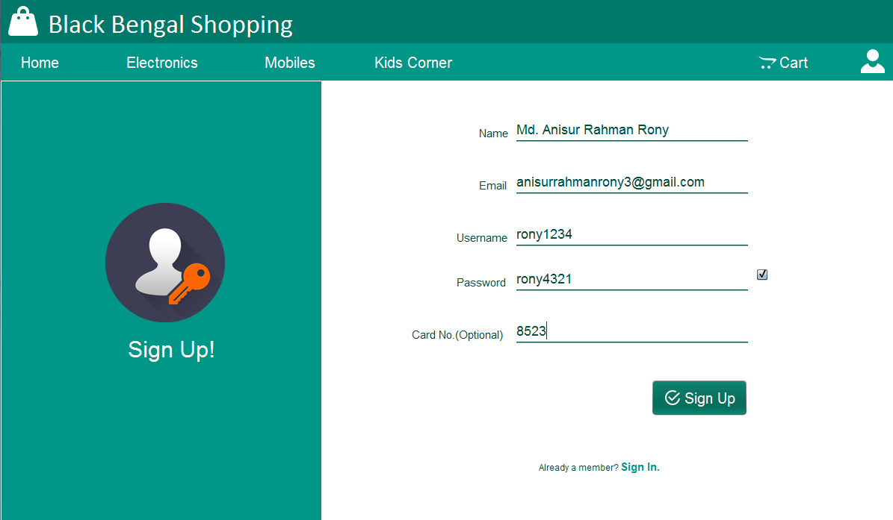

showing different types of product.
Different types of products will be shown .Such as in Home latest products will be products will be shown. There are three categories such as electronics, mobile and kids’ corner.

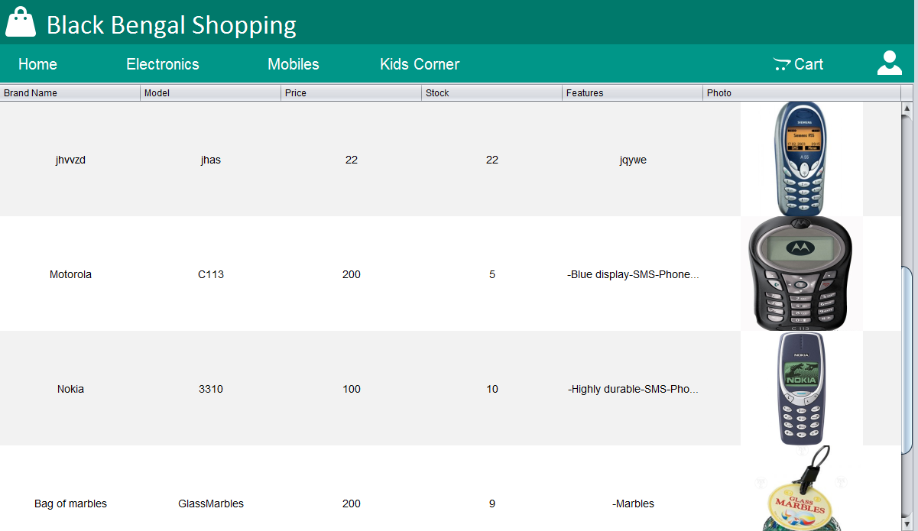
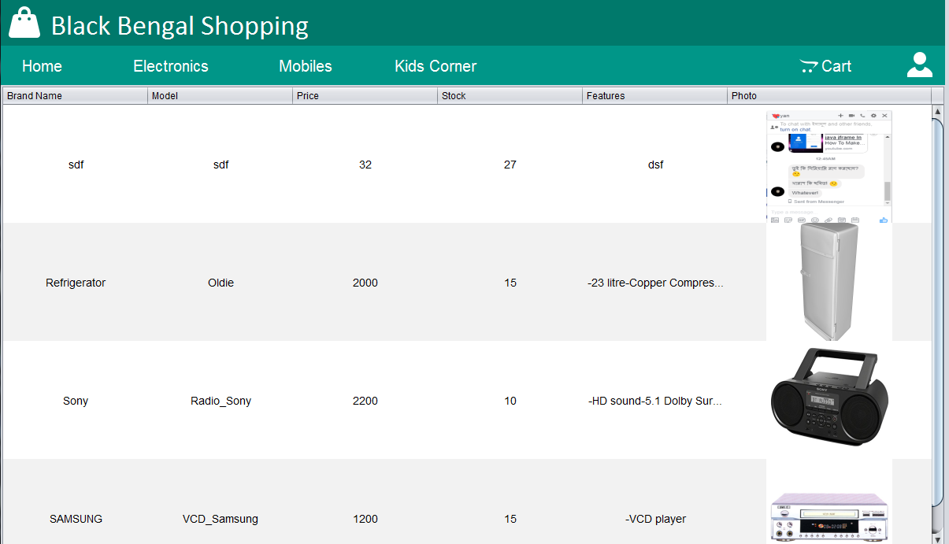

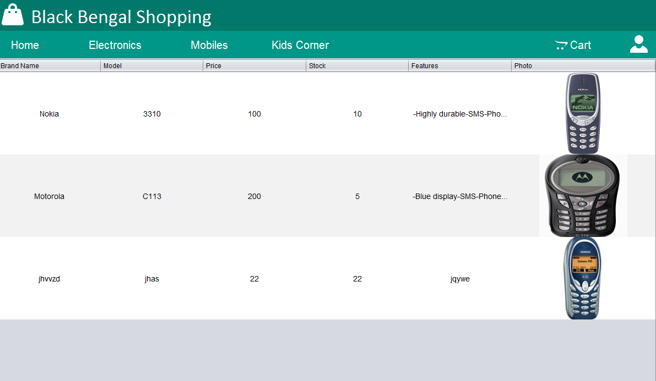

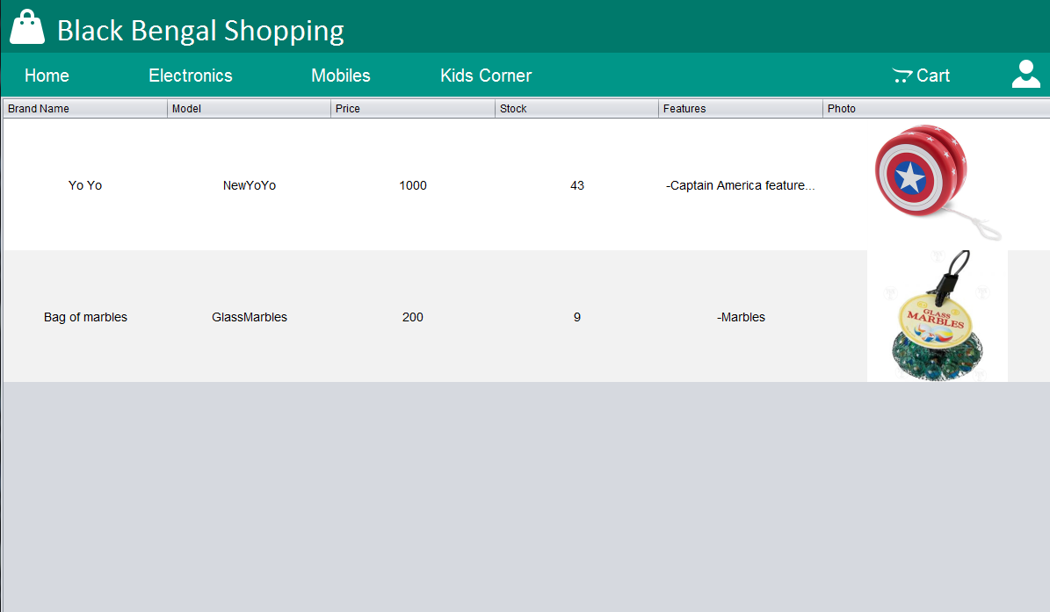

sign in for buying products

One must be sign in by using their Username and Password before buying a product. Before sign in one must be sign up first. If anyone forget his password a recovery option also has there. The password will be sent to the email of the customer (Which email he/she used during sign up)

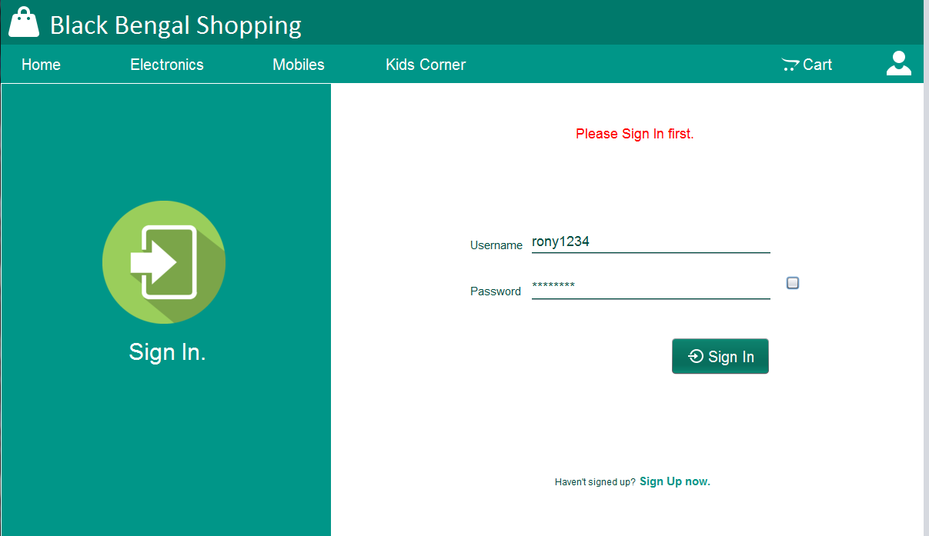

select product in the cart
After selecting products and their quantity in the cart, one can see the total cost and then can buy them from it. Here are the pictures of cart after selecting products with their total costs.

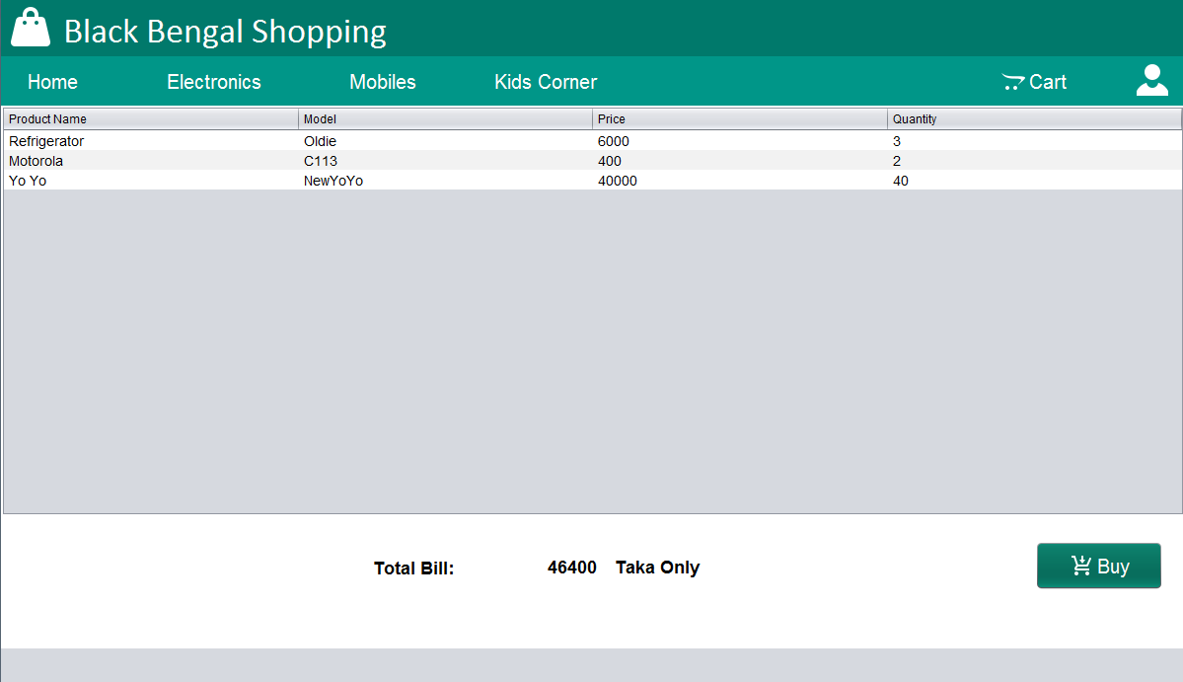

updating product

Admin can update any product by sign in as admin. He can include any other product, its details and for the effective selling.

.
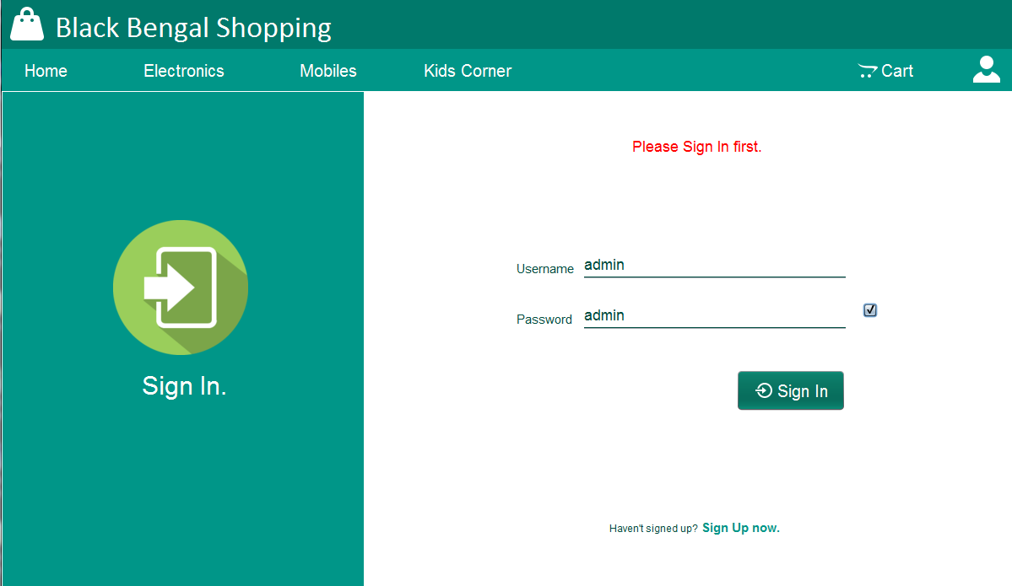

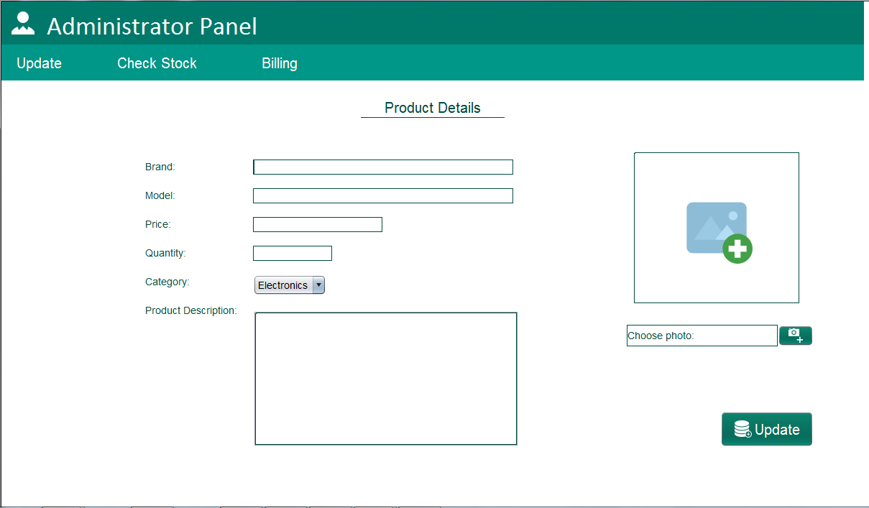
Conclusion: At last we can say that by using this project we can make our shopping/retailing (online) system easier and effective. It will save our times and we will get rid of hard works.

